Chapter-1
GENERAL INTRODUCTION
1.1 INTRODUCTION
Epidemiology may be defined as the science or study of disease as it occurs in groups. It can be considered to apply to any disease that affects the demos or crowd, and is not limited to the study of only such diseases as have epidemic expression. We can, therefore, properly include within the scope of epidemiological studies such conditions as cancer, silicosis, renal calculus, rheumatism, smelter chills, pernicious anemia, rickets, and even such social disorders or diseases as unemployment (Emerson, 1922).
Traditional Definition: “The study of communicable diseases that is temporarily prevalent in a community.”
Modern Definition (after 1950): “The study of all health-related states or phenomena prevalent in a community and their control. (Also include noninfectious diseases such as cancer, gout, obesity, etc.)”
Epidemiology helps to generate much of the information required by public health professionals to develop, implement, and evaluate effective intervention programmes for the prevention of disease and promotion of health, such as the eradication of smallpox, the anticipated eradication of polio and guinea worm disease, and the prevention of heart disease and cancer (Golding, 1992).
Use of mathematical techniques to understand the mechanisms leading to the spread of diseases and to evaluate effective strategies for its control is termed as Mathematical Epidemiology. Mathematical epidemiology includes the use of mathematical models to simulate the spread of diseases through different kinds of intervention strategies. An important role of mathematical models has been seen throughout the history of epidemiology. A mathematical model uses the language of Mathematics to produce a more refined and precise description of the system. Eykhoff (1974) defined a mathematical model as “a representation of the essential aspect of an existing system (or a system to be constructed) which presents knowledge of that system in usable form”.
The first step to construct a mathematical model of a system is to identify the variables that are responsible for changing the system and to select the important variables. Important variables are incorporated into the model. Thereafter, some reasonable assumptions about the system are made. The next step is to solve the mathematical model using mathematical tools like ordinary differential equations, partial differential equations, calculus and many more. A mathematical model can be solved manually as well as through computational techniques. Finally, the solutions are compared to known facts. If the solutions are consistent with facts, then the model is reasonable and if not, we increase level of resolution or alter the assumptions and reformulate the mathematical model.
Mathematical models may be deterministic or stochastic. A deterministic model is one in which every set of variable states is uniquely determined by parameters in the model and by sets of previous states of these variables. Conversely, in a stochastic model, randomness is present and variable states are not described by unique values, but rather by probability distributions (Wikipedia, 2008). Deterministic models are used extensively in mathematical modeling of dynamic systems. A mathematical model may also be classified into discrete or continuous. In discrete models, the state variables change only at a countable number of points in time. These points are the ones at which the event occurs/change in state. For example, many insects reproduce only once in seasonal environments and then die. The offspring that survive provide the reproductive base for next year's population. Continuous models are those in which the state variables change in a continuous way, and not abruptly from one state to another. In these types of models, time is continuous and that the populations under consideration reproduce continuously instead of seasonally. This phenomenon is more realistic for most of the species in the world. The analysis of mathematical models include the wellposedness of the models and their solutions, existence and stability of steady states, existence and stability of periodic solutions, persistence and occurrence of bifurcations etc.
We formulate our descriptions as compartment models in this thesis. Our models are formulated as a system of nonlinear ordinary differential equations. Here, it is assumed that the number of members in a compartment is a differentiable function of time. This is a reasonable assumption for large population size. Further, formulation of mathematical models as differential equations includes our assumption that the epidemic process is deterministic, that is, the behavior of a population is determined completely by its history and by the rules that govern the development of the model.
1.2 BASIC CONCEPTS OF MATHEMATICAL EPIDEMIOLOGY
Dynamics of a disease can be studied in two ways, we can study the spread and control of disease within a population and in some cases like cancer, study is done within the body of an individual. In the former case, the population is divided into compartments that transfer from one compartment to another depending upon our assumptions. Thus, depending upon the disease under consideration, we have different compartmental structures. However, in the latter case, modeling of cell-to-cell interactions occurring in a human body is done.
1.2.1 SOME COMPARTMENT MODELS
Mathematical models based on compartment structures were initially proposed by Kermack and McKendrick (1932) and developed later by many other biomathematicians. In the compartment models, population is divided mainly into following compartments:
- Susceptible compartment: It includes all the individuals that are prone to a disease. It is denoted by.
- Exposed compartment: It is denoted by and it includes all the individuals that have got infection but are not infectious.
- Infective compartment: Infective compartment constitutes all the infectious individuals. It is denoted by.
- Recovered compartment: It is denoted by. It consists of all the individuals that are recovered or removed from the infection.
Kermack and Mckendrick in 1926 formulated a well-known and well-recognized 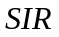 (susceptible–infective–recovered) model to study the outbreak of Black Death in London during the period of 1665–1666, and the outbreak of plague in Mumbai in 1906.
The flow chart of the model is as shown below:
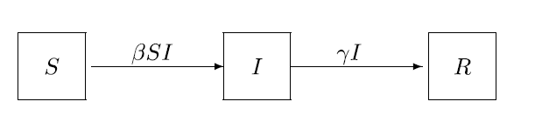
Fig.1, Flow chart of Model
The corresponding model equation for the system is,
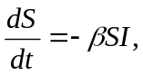
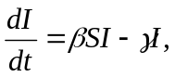 (1.2.1)
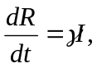
with 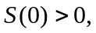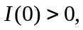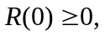
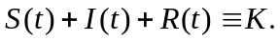
Where,  is the transmission coefficient of infection and is the recovery rate coefficient. The model described above is applicable for viral diseases like influenza, measles, and chickenpox, in which, the recovered individuals, gain immunity to the same virus. However, for bacterial diseases, such as encephalitis, and gonorrhea, the recovered individuals gain no immunity and can be infective again. For such cases, Kermack and Mckendrick proposed an 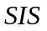 model. The flow chart of a model is as given below:
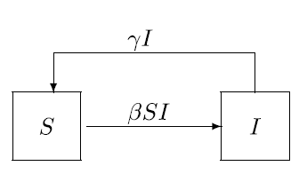
Fig.2, Flow chart of Model
The corresponding system of equations describing model is,
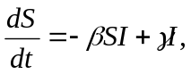
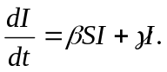 (1.2.2)
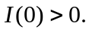
Since 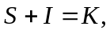 system (1.2.2) can be reduced to
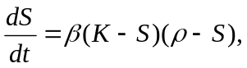 where 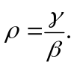 (1.2.3)
Similarly there are many other fundamental forms of compartment models like , 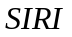 etc. We give here flow diagram of and model:
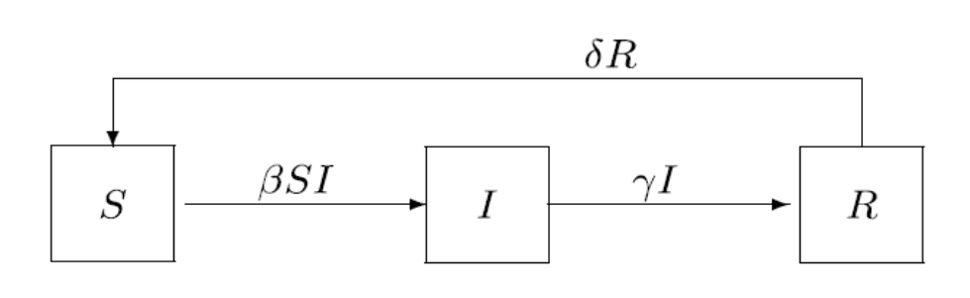
Fig.3, Flow chart of Model
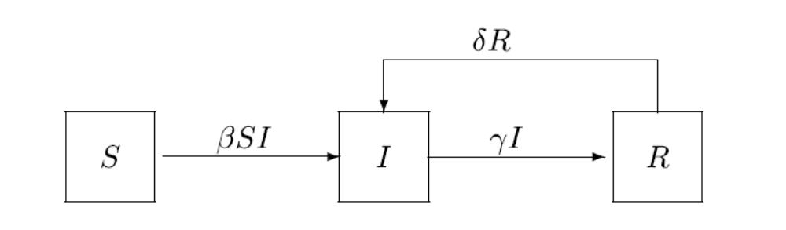
Fig.4, Flow chart of Model
In most of the diseases, there is an exposed period after the transmission of infection from infective to susceptible individual termed as latency period, or latent period. Latent period is the time between exposure to a disease-causing agent and the onset of the disease. There are various diseases with long incubation/latent period like Hepatitis, AIDS etc. Thus, time interval between the transitions of individuals from exposed class to infective class cannot be ignored. If we include an exposed compartment 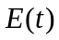, also in the model, we have , 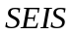, 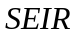, and  models with latent periods, respectively. For example, If is the progression rate coefficient for individuals from compartments to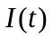, such that 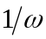 is the mean latent period, we have following flow chart for the system:
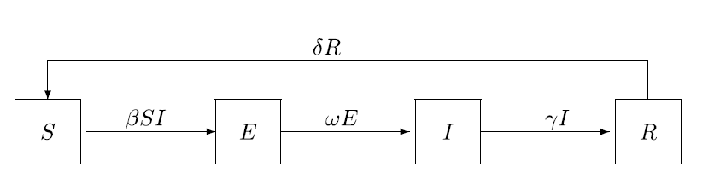
Fig.5, Flow chart of Model
Corresponding set of differential equations describing the flow chart of the model is,
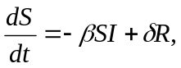
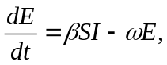 (1.2.4)
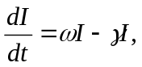
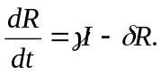
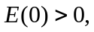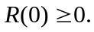
As progresses are being made in epidemic modeling, more realistic mathematical models for infectious diseases have been developed. Specifically, factors and structures, such as latent periods and time delays, age, other physiologic structures, and effects of isolations, quarantine, vaccination, or treatment can also be included.
1.2.2 MODELING CELLULAR INTERACTIONS
In order to study the dynamics of disease within the body of an infective individual modeling of cell-to-cell interactions occurring in a human body is done. The aim of using cellular models in this thesis is to reveal the basic laws that govern the spread of cancer cells, their interaction with the immune system and their response to the treatment. We also study the interaction of cancer cells with oncolytic viruses in the virotherapy. In this thesis, mathematical models of cancer growth and its treatment are based on prey-predator dynamics where cancer cells are prey and immune cells are predators (Banerjee and Sarkar, 2008; El-Gohary and Al-Ruzaiza, 2007).
The population dynamics of predator-prey interactions is modeled using the Lotka−Volterra equations, which is based on differential equations. Basic Lotka-Volterra model is given by
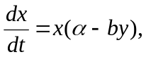
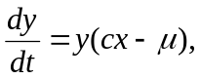 (1.2.5)
with the initial condition 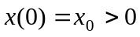and 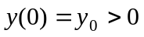.
Where, is the average birth rate minus the average death rate of the prey population. Volterra reasoned that the number of predator prey contacts per unit time is proportional to and to. This idea is implemented by introducing the simple term 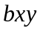 where is the parameter that indicates the efficiency of predation. Hence, the growth law for prey gets modified to become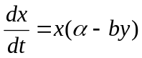. Volterra reasoned that population growth of predators is proportional to their current population, , and to the population of prey, , and so they increase at rate 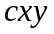 for constant 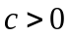. But they also die, and he reasoned that the death rate is simply proportional to current population, and equals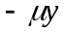.Thus, for predators, 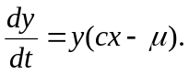
Banerjee, Sarkar (2008) considered prey–predator system to study the dynamics of interactions between immune cells (hunting and resting cells) and cancer cells. Similarly, Wodarz (Wodarz and Komarova, 2005) presented a mathematical model that describes interaction between two types of tumor cells (the cells that are infected by the virus and the cells that are not infected but are susceptible to the virus) and the immune system. The model is as given below:
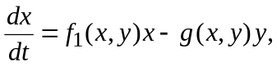
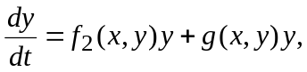
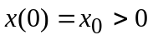and 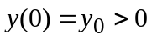.
Where and are the sizes of uninfected and infected cell populations, respectively; 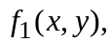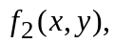are the per capita birth rates of uninfected and infected cells; and 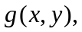is a function that describes the force of infection, i.e., the number of cells that are newly infected by the virus released by an infected cell per time unit. The functions used in (Wodarz, 2001) are
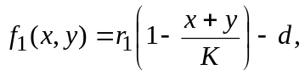
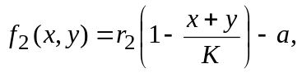
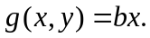
where 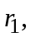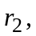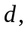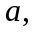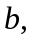are the nonnegative parameters. Tumor growth is assumed to be in logistic fashion and infection of oncolytic virus is assumed to be proportional to the product 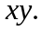 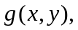called functional response is a crucial element in models of biological communities. Novozhilov et al., (2006) introduced ratio-dependent process of infection given by, 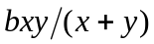 into the mathematical model of cancer growth. Huang, Ma and Takeuchi, (2011) studied a class of virus dynamics model with intracellular delay and nonlinear infection rate of Beddington-DeAngelis functional response, 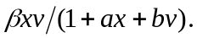Where, 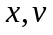are the density of cells and virus respectively and 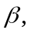 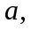 are positive constants. A suitable type of functional response that represents the incidence of a disease depends on the type of disease and the environment. Many forms of functional responses used in the studies of population dynamics inspire us to construct different forms of contact rates for various diseases and environments.
In the compartmental epidemic models, primarily there are two forms of contact rates; one is linearly proportional to the population size 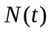 i.e.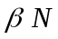 such that the corresponding incidence acquires the bilinear form given by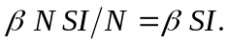 The other one is a constant which gives the standard form of incidence called standard incidence rate, 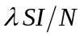. To describe transmission dynamics of diseases in more details, other nonlinear incidences are also proposed that are more plausible for some special cases. Capasso and Serio, (1978) used a saturated incidence of the form of 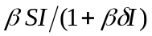, Liu et al., (1986, 1987) proposed nonlinear incidences of the form of 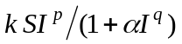and 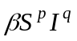.
1.2.3 BASIC REPRODUCTION NUMBER
Basic Reproduction Number is defined as “the average number of secondary
infections produced by one infective individual during the mean course of infection in a completely susceptible population,” and is denoted by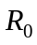 (Van den Driessche, Watmough, 2002). If 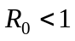, then on average, the number of new infections by one infective individual over the mean course of the disease is less than one, which implies that the disease dies out eventually. If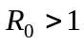, then the number of new infections produced by one infective individual is greater than one, which leads to the persistence of the infection.
1.3 HISTORICAL BACKGROUND
During the last decade, various mathematical models have been used for infectious diseases in general and for influenza in particular (Alexander et al., 2004; Ferguson et al., 2004; Derouich and Boutayeb, 2008). Indeed, many believe infectious diseases had greatly reduced the human population growth rates in the world prior to the 18th century (Brauer and Chavez, 2001). Derouich and Boutayeb (2008) presented a mathematical model dealing with the dynamics of human infection by avian influenza both in birds and in humans. They found that the dynamics of the disease is determined by the average number of adequate contacts of a human susceptible with infected birds. They determined a threshold parameter that was proved an essential key to preventive strategies against avian influenza. Along with the study of diseases dynamics, study of control measures is also an equally important task to make effective prevention strategies against such diseases. Contact tracing, followed by treatment or isolation, is one of the control measures in the battle against infectious diseases. Rutherford and Woo (1988) presented a model of HIV transmission to evaluate the effect of contact tracing to reduce the HIV infection. Aparicio and Hernandez (2006) studied the effect of contact tracing in tuberculosis. They modeled the average effect of this contact-tracing based strategy by assuming that only a fraction of the total of newly infected contacts of each new case of (pulmonary) active-TB, are elucidated and that those individuals received fully effective preventive chemo-prophylaxis. They modeled this by assuming that this fraction moves directly from the susceptible classes to a treated class. Isolation has been used to reduce the transmission of various human diseases as leprosy, plague, small pox, typhus, yellow fever and influenza etc. It has also been used for animal diseases such as foot and mouth, psittacosis, Newcastle disease and rabies. Chinviriyasit and Chinviriyasit (2007) studied global stability of a model for the transmission dynamics of infectious diseases with a new class of quarantined (isolated) individuals, who have been removed and isolated either voluntarily or coercively from the infectious class. Hethcote, Zhien, and Shengbing (2002) studied the effects of quarantine (isolation) in six endemic models for infectious diseases. They have found threshold equilibria and their stability for 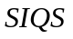 and 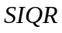 epidemiology models with three forms of incidence.
Despite of global eradication and control efforts, a disease that is reemerging in areas thought free of the disease is malaria. This has been attributed to a number of factors and most importantly human migration and travel (Wilson, 1998; Martens and Hall, 2000; Singh et al., 2003; López-vélez, Huerga and Turrientes, 2003). Historically, population movement has contributed to the spread of disease (Prothero, 1977). Failure to consider this factor contributed to failure of malaria eradication campaigns in the 1950s and 1960s (Bruce-Chwatt, 1968). The movement of infected people from areas where malaria was still endemic to areas where the disease had been eradicated led to resurgence of the disease. However, population movement can precipitate or increase malaria transmission in other ways as well. Mathematical models have long provided important insights into malaria dynamics and its control. Mathematical modeling of malaria began in 1911 with Ross’s model (Ross, 1911) and major extensions are described in Macdonald’s 1957 book (MacDonald, 1957). The first models were two dimensional with one variable representing human population and the other representing mosquitoes. Anderson and May (1991), Aron and May (1982), Koella (1991) and Nedelman (1985) have also given reviews on the mathematical modeling of malaria. Li et al. (2002) studied dynamic malaria models with environmental changes. Recent literature on malaria includes the work of Chilundo, Sundby and Aanestad (2004), Singh, Shukla and Chandra (2005), Abdu-Raddad, Patnaik and Kublin (2006) etc.
Along with the mathematical models on infectious diseases, a large variety of literature on the dynamics of cancer is also present. Geneticists and cell biologists have uncovered so much of basic cell mechanisms that at least the broad outlines of how cancer cells develop and act are now easier to understand (reviews from Lundberg and Weinberg, 1999; Hannahan and Weinberg, 2000 and Hahn and Weinberg, 2002). Several authors have also suggested different mathematical models of the cancers that are helpful in studying some essential characteristics of cancer cell kinetics (Boer et al., 1985; Boer and Hogeweg, 1986; Kirschner and Panetta, 1998; Villasana and Radunskaya, 2003; Kuang, 2004; Byrne et al., 2004; Sarkar and Banerjee, 2005). In recent years, the effect of immunotherapy on the interactions between tumor cells and immune-system cells has been mathematically modeled by some dynamical systems (reviews from Preziosi, 2003; Kuznetsov and Taylor, 1994; Kirschner and Panetta, 1998; Kolev 2003). A good summary of cancer and immune cell interactions can be found in Preziosi (2003). Kuznetsov and Taylor (1994) presented a mathematical model of the cytotoxic T lymphocyte response to the growth of an immunogenic tumor. Through mathematical modeling, Kirschner and Panetta (1998) have illustrated the dynamics between tumor cells, immune effector cells and interleukin-2 (IL-2). Their efforts explain both short-term tumor oscillations in tumor sizes as well as long-term tumor relapse. They have also explored the effects of immunotherapy on tumor model and have described under what circumstances the tumor can be eliminated. Kolev (2003) presented a mathematical model, showing competition between tumors and immune system by considering the role of antibodies. The model is developed with statistical methods and is expressed in terms of a system of integrodifferential equations. Yafia (2006a, b) studied Hopf bifurcation and stability of limit cycle in a delayed model for tumor immune system with negative immune response.
Mathematical modeling of virus-cell interaction has a long history (reviews from Nowak and Bangham, 1996; Nowak and May, 2000). The unquestionable success of mathematical models of certain virus-host systems, in particular, HIV infection (Ho et al., 1995; Wei et al., 1995), provides for a reasonable hope that substantial progress can be achieved in other areas of virology as well including their application in treatment of cancer. Oncolytic viruses are viruses that specifically infect and kill cancer cells but not normal cells (Kirn and McCormick, 1996; McCormick, 2003; Kasuya et al., 2005). Many types of oncolytic viruses have been studied as therapeutic agents including adenoviruses, herpesviruses, and reoviruses (Kasuya et al., 2005). The interactions between the growing tumor and the replicating virus population are complex and nonlinear. Hence, mathematical models are needed to precisely define the conditions required for successful therapy by this approach. Wodarz and Komarova (2005) presented a mathematical model that describes interaction between two types of tumor cells (the cells that are infected by the virus and the cells that are not infected but are susceptible to the virus so far as they have cancer phenotype) and the immune system. Other mathematical models for tumor-virus dynamics are mainly spatially explicit models that are described by systems of partial differential equations. However, the local dynamics in these models is usually modeled by systems of ordinary differential equations that bear close resemblance to a basic model of virus dynamics (Nowak and Bangham, 1996). Wu et al. (2001) modeled and compared the evolution of a tumor under different initial conditions. Friedman and Tao (2003) presented a rigorous mathematical analysis of a different model. The partial differential equation for the virus spread is the main feature that distinguishes the model of Friedman and Tao (2003) model from the model of Wu et al. (2001). Wein et al. (2003) incorporated immune response into their earlier model (Wu et al., 2001). Wein et al. (2003) discussed the design of oncolytic viruses. They suggested that viruses should be designed for rapid intratumoral spread and immune avoidance, in addition to tumor-selectivity and safety. Wu et al. (2004) made some analysis using ordinary differential equations which is a simplified approximation to their partial differential equation model and bears some similarities to the model of Wodarz. Tao and Guo (2005) extended the model of Wein et al. (2003) and proved global existence and uniqueness of solution in their new model. They studied the dynamics of this novel therapy for cancers, and explored an explicit threshold of the intensity of the immune response for controlling the tumor. Wodarz (2003) suggested a model based on his previous work to study advantages and disadvantages of replicating versus non-replicating viruses.
The role of hepatitis virus specially and  in causing liver cancer is well established. It is found that the frequency of liver cancer correlates with the frequency of chronic hepatitis virus infection. Primarily because of hepatitis significance as a global public health threat, the virus and its associated diseases have attracted considerable attention from mathematical and theoretical biologists ( reviews from Gourley, Kuang and Nagy, 2008; Eikenberry et al., 2009; Min, Su and Kuang, 2008; Nowak et al., 1996; Ciupe et al., 2007). Gourley, Kuang and Nagy (2008) studied the dynamics of a Hepatitis B Viral infection model with logistic hepatocyte growth. They found that the disease free steady state is stable when viral basic reproductive number is less than one. However, when it exceeds one, the system can either converge to the chronic steady state, experience sustained oscillations, or approach the origin. Eikenberry et al. (2009) explored the dynamics of a delay model of hepatitis virus infection with logistic hepatocyte growth. They found that when the basic reproductive number is greater than one there exists a biologically meaningful chronic steady state, and the stability of this steady state is dependent upon both the rate of hepatocyte regeneration and the virulence of the disease. When the chronic steady state is unstable, an attracting periodic orbit exists. They explained sudden onset of liver failure in chronic 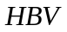 patients is due to a switch in stability caused by the gradual evolution of parameters representing the disease state.
1.4 WORK DONE IN THE THESIS
This thesis, devoted to the mathematical epidemiology is organized into seven chapters containing mathematical models of diseases like flu and malaria and some models on cancer growth and its treatment. Models are analysed using stability theory of differential equations. Moreover, the numerical simulation of the proposed models is also performed by using fourth order Runge - Kutta method to justify the analytical findings.
Chapter two deals with a nonlinear mathematical model to study the dynamics of 2009 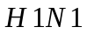 flu epidemic in a homogeneous population with constant immigration of susceptibles. The effect of contact tracing and isolation strategies in reducing the spread of flu is incorporated. The model monitors the dynamics of five sub-populations , namely susceptibles with high infection risk, susceptibles with reduced infection risk, infectives, isolated and recovered individuals. The model analysis includes the determination of equilibrium points and carrying out their stability analysis in terms of the threshold parameter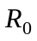. The analysis and numerical simulation results demonstrate that the maximum implementation of contact tracing and isolation strategies help in reducing endemic infective class size. This gives a theoretical interpretation to the practical experiences that contact tracing and isolation strategies are critically important to control the outbreak of epidemics.
Third chapter deals with another persistent tropical disease that has emerged out as one of the major epidemics in the world, malaria. India also has a long history of attacking malaria. Despite of global eradication and control efforts, malaria is reemerging in areas where control efforts were once effective and emerging in areas thought free of the disease. Considering this into account, this chapter considers a host-vector mathematical model for the spread of Malaria that incorporates recruitment of human population through a constant human migration and travel. It is found from our analysis that due to immigration of infective and exposed population in the community, infective human population level rises. In addition, it is found that infective human population reduces by preventing mosquitoes to bite infective human population and by decreasing the probability of transmission of infection from human to mosquitoes and vice a versa.
After studying the dynamics of infectious disease models like flu and malaria, we analyze some mathematical models on cancer growth and its treatment from chapter fourth onwards. Fourth chapter deals with a generalized model describing the interaction between cancer and immune cells as a deterministic prey-predator like model. Mathematical analysis of the model equation with regard to boundedness of solutions, nature of equilibrium points and their local and global study is done. Numerical analysis is performed to support analytical findings. It is observed that cancer cell population decrease considerably due to proliferation of lymphocytes mediated by immunotherapy. It is found from our analysis that cancer population can be controlled easily if cancer is immunogenic that is, cancer cells possess distinctive surface markers. These surface markers are called tumor-specific antigens.
In chapter sixth, we propose and analyze a nonlinear mathematical model to study the effect oncolytic virotherapy. We analyse complex interaction among growing cancer cells and replicating virus population. It is observed from our study that replication of oncolytic virus within cancer cells and their transmission to other cancer cells is responsible for the infection among more cancer cells and hence increase in the number of infected cancer cells. In this process number of uninfected cancer cells decrease automatically. Further, it is found that as cytotoxicity rate of oncolytic virus increase infected cancer cells decrease on the other hand uninfected cancer cells increase. Equilibrium level of infected cancer cells decrease because oncolytic virus kill cancer cells by infecting them. But it is not able to annihilate the proliferation of cancer cells. Therefore, number of uninfected cancer cells keeps on proliferating in the human body. In addition, the model is extended by including the effect of antiviral immune response on the model. It is found that active proliferation of immune cells is helpful in eliminating cancer cells from the body.
The seventh chapter of thesis is a non – linear mathematical model to demonstrate the relation between hepatitis and cancer in a homogeneous population with constant immigration of cancer patients in the community. Both the horizontal and vertical mode of transmission of hepatitis in the population is considered. Sensitivity analysis of the endemic equilibrium to changes in the value of the different parameters associated with the system is done. Modeling the effect of hepatitis virus infections among cancer patients and their impact on the increase in spread of hepatitis among the population is the novel feature of our model. It is concluded from the analysis that if the rate of transmission of hepatitis infection increases, the endemic level of infective population increases which can further be enhanced if risk of hepatitis infection among cancer patients also increases. Further, it is found from our analysis that hepatitis infection leads to an increase in number of cancer patients in the population because of the progression of hepatitis and infection to liver cancer.
1.5 DEFINITIONS AND THEOREMS USED IN SUBSEQUENT CHAPTERS
1.5.1 EQUILIBRIUM POINT
Equilibrium is a point at which a variable (or variables) remains unchanged over time. It is a constant solution of the system of differential equations.
In mathematics, the point 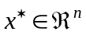 is an equilibrium point for the differential equation 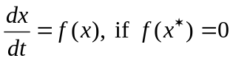for some value of.
Geometrically, equilibrium is a point in the phase plane that is the orbit of a constant solution.
1.5.2 REGION OF ATTRACTION
Consider an autonomous nonlinear system 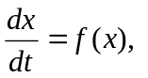with an asymptotically stable equilibrium point and denote the trajectory with initial condition 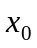 as 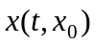. The region of attraction of is 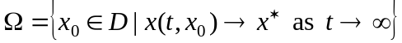.
Thus, a region of attraction is a part of phase space including the equilibrium points and initial conditions from which a trajectory will converge to the equilibrium points.
1.5.3 STABILITY
Stability properties characterize how a system behaves if its state is initiated close to, but not precisely at a given equilibrium point.
- If a system is initiated with the state exactly equal to an equilibrium point, then by definition it will never move.
- When initiated close by, however, the state may remain close by, or it may move away.
An equilibrium point is stable whenever the system state is initiated near that point, the state remains near it, perhaps even tending towards the equilibrium point as time increases. In particular, equilibrium is said to be stable if every solution 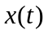with 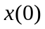sufficiently close to the equilibrium remains close to it for all 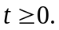
An equilibrium is said to be asymptotically stable if it is stable and if, in addition, solutions with sufficiently close to the equilibrium tend to equilibrium as 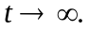
Theorem 1.5.1 The equilibrium point is asymptotically stable if it is stable and if there exist 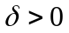such that
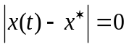
for all 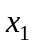satisfying 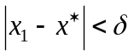
On the other hand, when small perturbations continue to move away from the equilibrium, the equilibrium point is said to be unstable.
An equilibrium is globally stable if a system approaches the equilibrium regardless of its initial positions.
Theorem 1.5.2 Consider an autonomous nonlinear systemand let is its equilibrium point. The equilibrium point is said to be globally asymptotically stable (asymptotically stable in the large) if it is asymptotically stable and every trajectory starting in 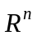 converges to for
1.5.2.1 Lyapunov Stability Theory:
Definition 1.5.1 (Positive and negative definite functions)
A continuously differentiable function 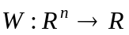 is said to be positive definite in a region  of that contains the origin if
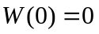 and 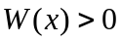for  and 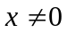.
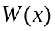is said to be positive semidefinite if 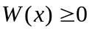for and 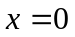.
Conversely, if 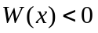, then is said to be negative definite. is said to be negative semidefinite if 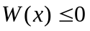.
Definition 1.5.2 (Continuous Differentiability)
A function 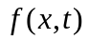 where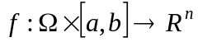 for a domain 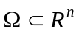is said to be continuously differentiable over on 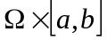if both and 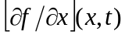are continuous on .
Notice that continuous differentiability over a domain implies the local Lipschitz property.
For the complicated systems, explicit solutions for  are rarely available. Without such solutions, however, system behavior cannot be directly evaluated. Lyapunov (1892) recognized this difficulty and developed stability criteria for autonomous system.
Theorem 1.5.4 (Lyapunov stability of autonomous systems): Let 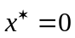 be an equilibrium point for a system described by:
where 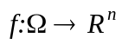is a locally Lipschitz and a domain that contains the origin.
- If 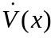is negative semidefinite, that is 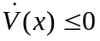 for all (where ‘·’ designates the differentiation) then is a stable equilibrium point.
- If is negative definite, that is 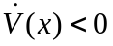 for all then is an asymptotically stable equilibrium point.
In both cases above is called a Lyapunov function. Moreover, if the conditions hold for all 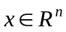and 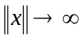implies that 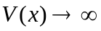, then is globally stable in case 1 and globally asymptotically stable in case 2.
1.5.4 ROUTH-HURWITZ STABILITY CRITERION
The criteria that give necessary and sufficient conditions for all the roots of the characteristic polynomial (with real coefficients) to lie in the left half of the complex plane are known as the Routh Hurwitz criteria. The name refers to E.J. Routh and A. Hurwitz, who contributed to the formulation of these criteria. They are used to determine local asymptotic stability of an equilibrium point for nonlinear systems of differential equations.
(Routh Hurwitz Criteria) Given the polynomial
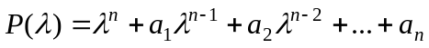,
where the coefficients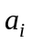are real constants, 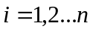., define the Hurwitz matrices using the coefficientsof the characteristic polynomial:
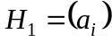, 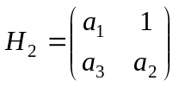, 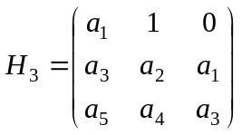....
and 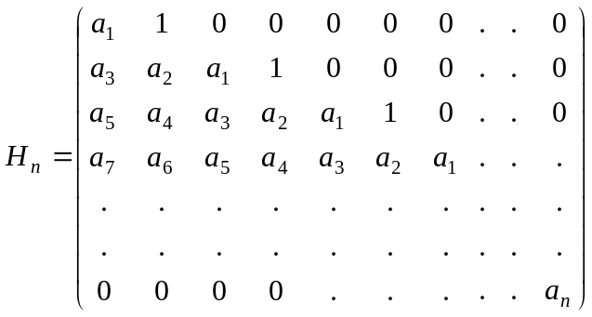
where 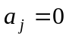for 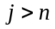. All the roots of polynomial 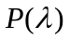are negative or have negative real parts iff the determinants of all Hurwitz matrices are positive:
det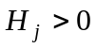, 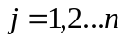.
For 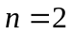,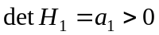 and 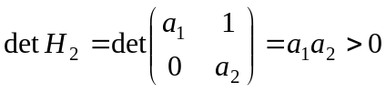
or 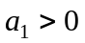and 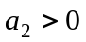.
For polynomials of degree 2,3,4 and 5, the Routh Hurwitz Criteria are summarized as follows:
: and .
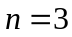: 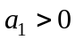, 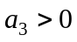 and 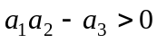.
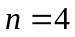: ,,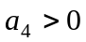and 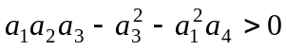
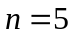: 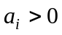, 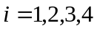and 5, and
1.5.5 HOPF BIFURCATION
A bifurcation occurs when a small smooth change made to the parameter values (the bifurcation parameters) of a system causes a sudden 'qualitative' or topological change in its behavior (Blanchard, Devaney and Hall, 2006).
If we consider the continuous dynamical system described by the ordinary differential equations:
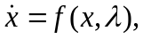 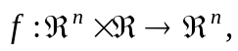 a bifurcation occurs at 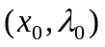if the corresponding Jacobian matrix has an eigenvalue with zero real part. If the eigenvalue is equal to zero, the bifurcation is a steady state bifurcation, but if the eigenvalue is non-zero but purely imaginary, this is a Hopf bifurcation. Hopf bifurcation is a very important dynamic phenomenon in epidemiology. It can be used to interpret the periodic behavior for some infectious diseases. Time delay models often exhibit Hopf bifurcation in the system. Delay can cause the loss of stability and can bifurcate various periodic solutions. When value of delay passes through a critical point, the positive equilibrium loses its stability and a Hopf bifurcation occurs. Hale and Lunel (1993) gave the following condition for Hopf-bifurcation yielding the periodic solution
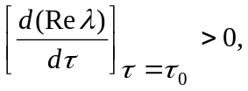
This signifies that there exists at least one eigenvalue with positive real part for 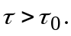
1.6 DIRECTIONS FOR FUTURE WORK
A deep inside in mathematical biology has opened up different area of research in epidemiology in the last few decades. Mathematical modeling on the dynamics of diseases has played a pivotal role in understanding the mechanism of the spread and the transmission dynamics of the diseases and establish better strategies for useful predictions and guidance. A great deal of mathematical modeling has been accompanied by a rich theory of differential equations.
The effect of seasonal variations (wet and dry seasons) on the spread of various diseases like malaria can be considered. Since the conditions favourable for the spread of diseases varies periodically, introduction of seasonal variation in the model may provide better results.
In cancer growth models, exact mode of interaction among cancer cells and cancer and immune cells is not yet known, hence, formulation of a better interaction term is an open problem.
Epidemic models and models on cancer growth often exhibit bifurcation and chaotic behavior. Study of chaos and bifurcation in these models will assume greater importance in the near future since the application of the theory to the field of epidemiology can be helpful in deciding drug doses and in establishing better prevention strategies against the diseases.

